**Ideation Phase**

**Define the Problem Statements**

|  |  |
| --- | --- |
| Date | 17 October 2022 |
| Team ID | PNT2022TMID12856 |
| Project Name | Real-Time River Water Quality Monitoring and Control System |
| Maximum Marks | 2 Marks |

**Customer Problem Statement Template:**

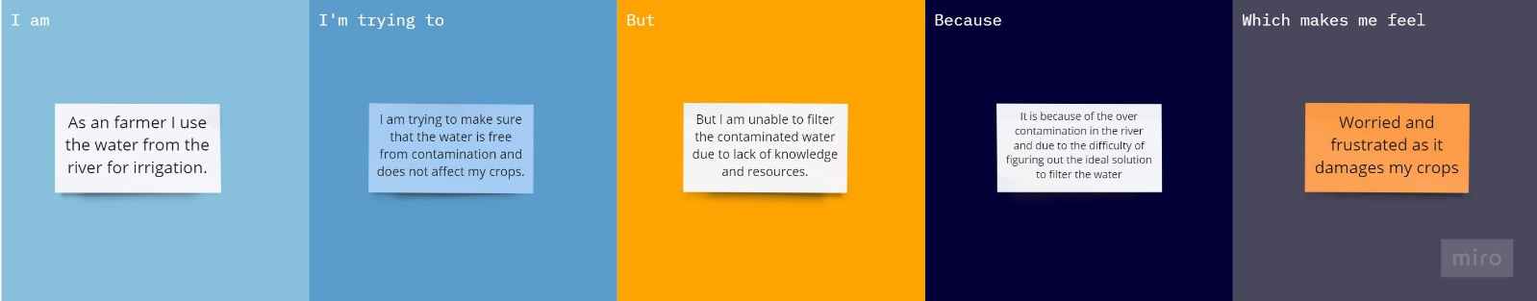

Reference: <https://miro.com/templates/customer-problem-statement/>

|  |  |  |  |  |  |
| --- | --- | --- | --- | --- | --- |
| **Problem**  **Statement (PS)** | **I am (Customer)** | **I’m trying to** | **But** | **Because** | **Which makes me feel** |
| PS-1 | As a farmer I use the water from the river for irrigation. | I am trying to make sure that the water is free from contamination and does not affect my crops. | But I am unable to filter the contaminated water due to lack of knowledge and resources. | It is because of the over contamination in the river and due to the difficulty of figuring out the ideal solution to filter the water. | Worried and frustrated as it damages my crops. |
| PS-2 | I’m a  Fisherman | I fish in the river and sell the fishes I catch for a living. I couldn’t find any fishes in the river most of them are dead and the breeding has drastically reduced. | But each time I require information about river water quality for analysis. Lack of knowledge on the | Because, I can't do my task on time since evaluating  the river water quality takes additional time. | To fish, I require an automated river water management and control system. |